**The Book of Lord Shang: Foundations of Feudal Control**

Henry Zhang

The enduring prevalence of feudal rule in ancient China can be traced back to foundational works like The Book of Lord Shang (Shang Junshu), a text deeply influential yet shrouded in secrecy. While strictly forbidden among the common people, it was meticulously studied by feudal emperors as a vital source of governance strategies. The book, devoid of openly offensive remarks or vicious satire, nonetheless conveys a chilling disdain for the common people, portraying them as mere pawns to be manipulated. Its core ideas provided emperors with tactical frameworks to enforce control and foster blind obedience. Since the Qin Dynasty, these seeds of submission and slavery, deeply embedded in society, persisted for centuries, shaping the psyche of the people and entrenching their subjugation.

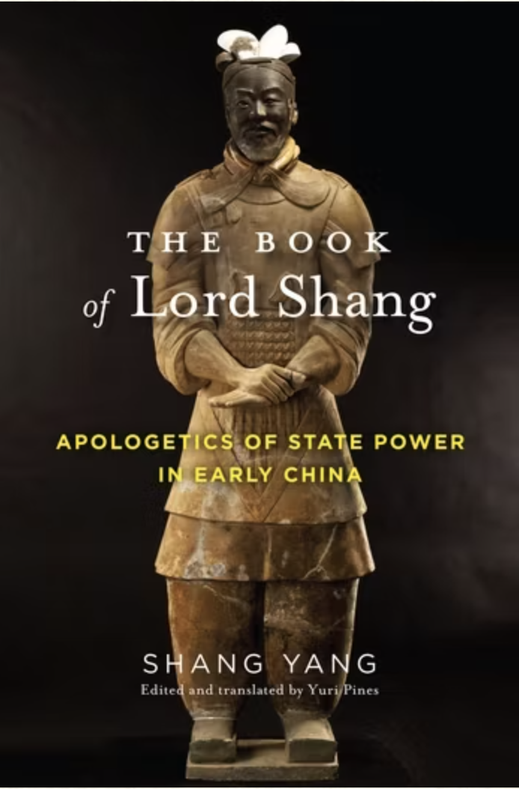

(The Book of Lord Shang,2025)

## **Book Overview and Author**

The Book of Lord Shang (Shang Junshu, 商君书), authored by Shang Yang (390–338 BCE), encapsulates his legalist philosophy and serves as a guide for emperors on ruling the country (ChinaKnowledge.de, n.d.). This text, also known as Shangzi, centers on the principle of "weakening the people and strengthening the state." Shang Yang posited that the state and its people exist in a state of inherent conflict: when the people are strong, the state is weak, and conversely, when the state is strong, the people must be weakened. To achieve national strength, Shang Yang advised the rulers of Qin to systematically weaken their populace. In the book, Shang Yang outlines five key techniques for controlling the people: stupidity, weakness, poverty, fatigue, and humiliation. Each of these strategies was designed to suppress the potential power of the masses, ensuring their submission while bolstering the authority and strength of the state.

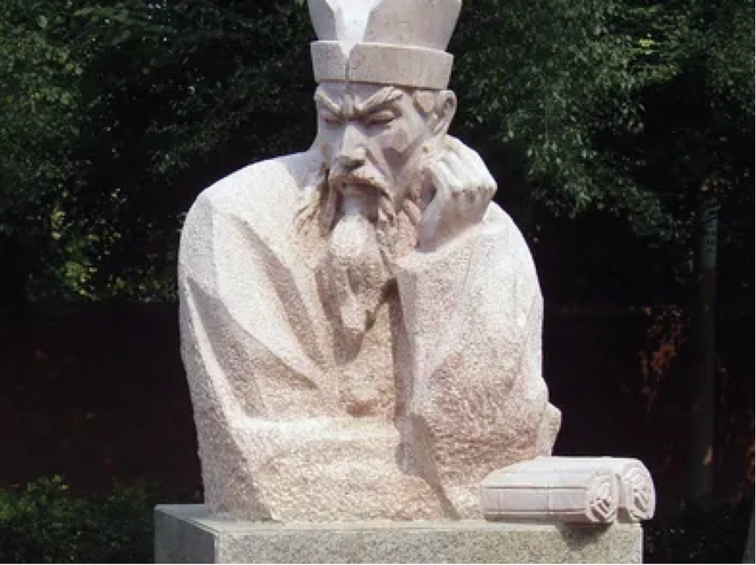

(Shang Yang, 2025)

Shang Yang was a prominent statesman and legalist philosopher during the Warring States period in ancient China. As a high-ranking official in the State of Qin, he implemented transformative legal and administrative reforms that significantly strengthened the state, paving the way for its eventual unification of China under the Qin Dynasty. While The Book of Lord Shang is a compilation of essays and discourses on governance and legalist principles, many sections are believed to reflect Shang Yang's own ideas and policies. Likely compiled by later scholars or followers of legalism after his death, the book systematically expounds on legalist thought, emphasizing strict laws, centralized authority, and the subjugation of individual interests for the benefit of the state (Pines, Y, 2017).

## **Core Ideology**

The primary purpose of Shang Yang's legal reforms was to strengthen the centralization of the state through a series of political, economic, and military measures. These reforms aimed to enhance the state's military power and social productivity, thereby increasing the comprehensive national strength of the State of Qin and ensuring lasting peace and stability.

Shang Yang's reforms were designed not only to address the intense competition of the Warring States period but also to enable Qin to stand out among the many powerful states and ultimately achieve dominance. The specific goals of these reforms included the following:

1. **Centralization of Power**: The reforms weakened the power of the nobles, increased the central government's authority, and centralized resources. This was achieved through changes to the land and tax systems, ensuring the effective operation of the state.
2. **Establishment of a Rule-of-Law Society**: The reforms strengthened the rule of law by implementing a harsh legal system and establishing a unified, strict legal framework. This restrained the behavior of both the people and the nobles, ensuring social order and preventing the formation of rebellious forces against the state and its rulers.
3. **Economic Reform**: Agricultural production was promoted, the tax system was improved, and the management of peasants was strengthened. By reforming the land system, land transfer and taxation became more efficient, increasing the state’s financial revenue.
4. **Military Reform**: Changes to the military service system, along with the implementation of the “guilt-by-association law” and the “military merit system,” incentivized soldiers and citizens to actively participate in military endeavors, thereby enhancing the country’s military power.
5. **Social Mobilization**: Through the introduction of the “household registration system” and the rewarding of military service, the reforms stimulated the people’s motivation and loyalty. This provided the state with a consistent supply of laborers and soldiers.

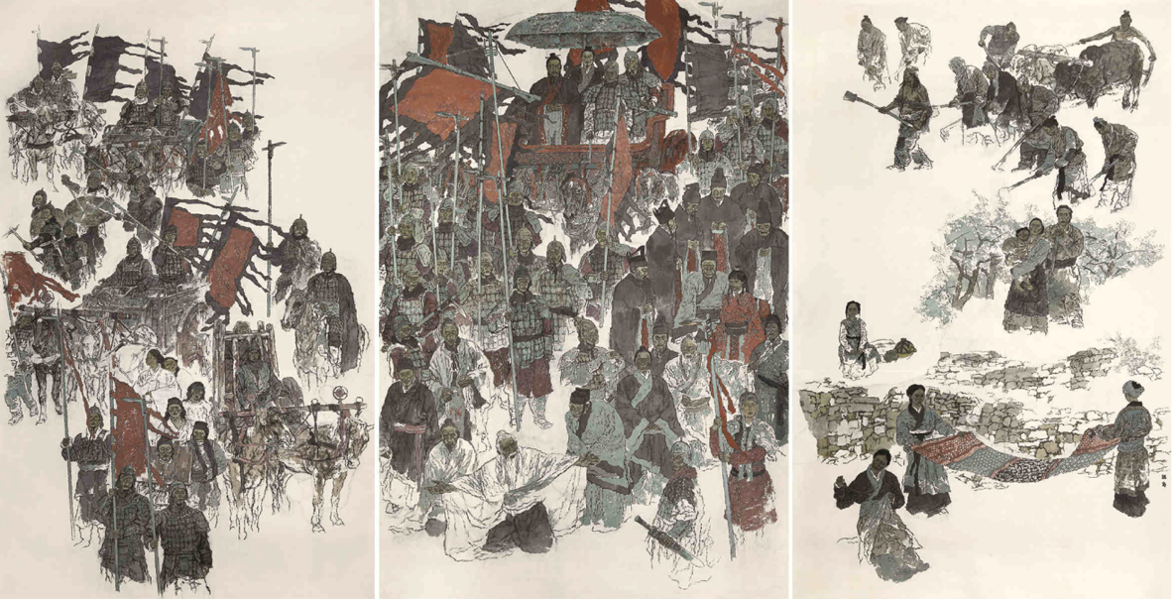

(赵奇, 2018) – Illustration of Shang Yang's Reform

**Chinese Character “民” – “People”**

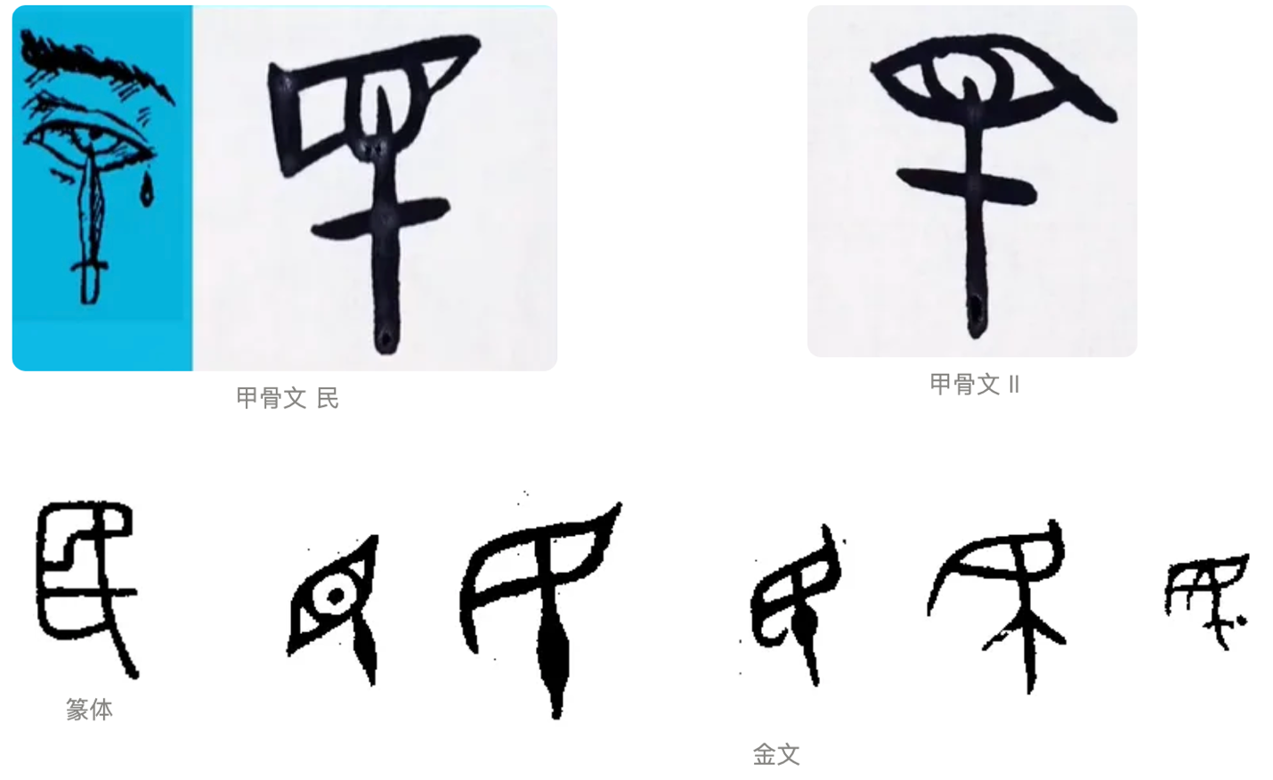

(Chinese Character “民” – “People”)

Why is the word "people" symbolized as blinded? During the oracle-bone period, the term "people" did not exclusively refer to the general populace. The depiction of a "blinded" person in this context likely referred to individuals such as criminals, war captives, or slaves owned by the ruling aristocracy. To subjugate these individuals and force them to work, the ruling class is believed to have blinded one eye to prevent escape.

In the Jinwen script of the Zhou Dynasty, the character “民” gradually evolved with societal development to mean "the people" ruled by the authorities. The shape of the character originated from the lower-class individuals, who would lower their eyebrows when encountering someone of high status (博物馆世界, 2022).

## **The Five Arts of Harnessing the People**

Based on the central idea of "suppressing the potential power of the masses, ensuring their submission while bolstering the authority and strength of the state," the people could be suppressed in various ways to make the Qin Dynasty stronger. The infamous "Five Techniques of Harnessing the People" were conceived and recorded in The Book of Shang Jun. These five techniques are Foolishness, Weakness, Poverty, Fatigue, and Humiliation (愚、弱、贫、疲、辱).

### **愚 - Foolishness**

The purpose of the Fool is to turn people into ignorant, productive machines devoid of independent personality, focused solely on labor. The Book of Shang Jun argues that the function of humanity can be reduced to two essential roles: in times of peace, people are to toil in the fields to generate wealth for the court; in times of war, they must dedicate themselves to killing the enemy and defending the king. Any actions beyond these roles are considered unnecessary.

According to the Historical Records of the Shang Jun Lianzhuan, during the implementation of Shang Yang's reforms, there were initially those in Qin who found the new decrees inconvenient and others who found them beneficial. Shang Yang responded by declaring these individuals to be agents of disorder and exiling them to distant border cities. This drastic measure silenced all criticism, as no one dared to speak against or in favor of the government’s decrees. The objective was clear: to ensure that the people would neither question nor praise the emperor's orders. Ultimately, the populace accepted the decrees in their entirety, ceasing to consider their validity or fairness, thus achieving a state of complete and blind obedience. Reading was deemed particularly unnecessary; knowing too much about irrelevant matters, it was argued, would lead people to take actions they should not. Consequently, Shang Yang initiated the banning of a range of classical texts.

Shang Yang labeled the earliest textbooks—Rites, Music, Poetry, and Books—as the foremost among the "six lice," condemning them as the "customs of a failed state." The absence of books, he reasoned, would prevent people from overthinking and allow them to focus solely on farming. To further restrict access to knowledge, Shang Yang proposed prohibiting Confucian scholars, ministers, and high-ranking officials from traveling to study and teach, effectively closing off avenues for the acquisition of knowledge and information (Tangly, 2024).

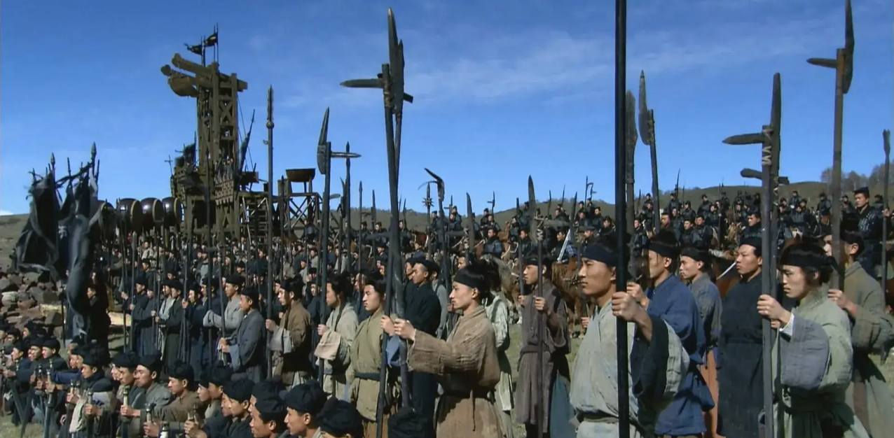

(沈烈康,2025) - **Shanghainese Halberd**

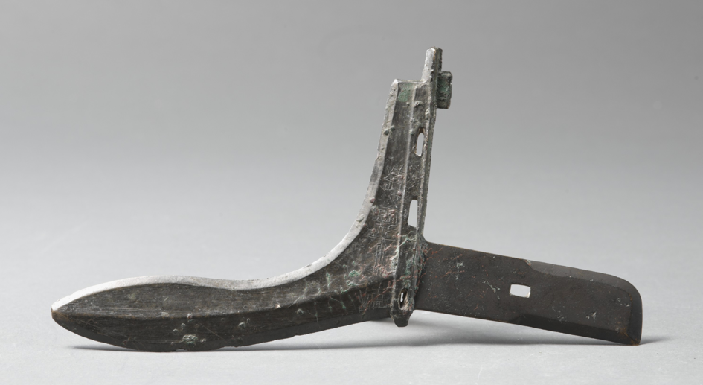

(商鞅戟, 2015) - **Shanghainese Halberd**

**Shanghainese Halberd**

The Shanghainese halberd, inscribed with the directive "in times of war, to dedicate oneself to killing the enemy and defending the king," directly reflects the core principle of Shang Yang's legalist ideology, which emphasized total loyalty and obedience to the state, especially during times of conflict.  
  
The halberd is raised at the ridge, with a rectangular shape and three open edges inside. The front and back of the Hu are inscribed with a total of 10 characters, which read: "Thirteenth year, DALANGZHAO YANGZHOU ZHOUZHI halberd." This halberd was issued in the thirteenth year of Duke Xiaodong of Qin (349 BCE), when Shang Yang was appointed as Da Liang Zao. (商鞅戟, 2015)

### **弱 – Weakness**

Weakness refers to the objective conditions that render people incapable of resistance or posing a threat, as absolute violence leads to absolute obedience. Constrained by the technological capabilities of the time, the upper limit of the court's force could not be significantly increased. Therefore, the focus was on lowering the lower limit of the force of ordinary people to neutralize any potential threat. As a result, aside from agricultural tools, people were strictly prohibited from owning iron and copper weapons. The famous saying, "to collect all the soldiers in the world and cast twelve of them in gold to weaken all the people in the world," clearly summarized this practice. According to the Historical Records of the First Emperor of Qin (秦始皇本紀), after Qin Shi Huang unified the six states, he collected a large number of weapons from across the country, destroyed them, and cast them into twelve gold statues, each weighing 450,000 kilograms (Tangly, 2024).

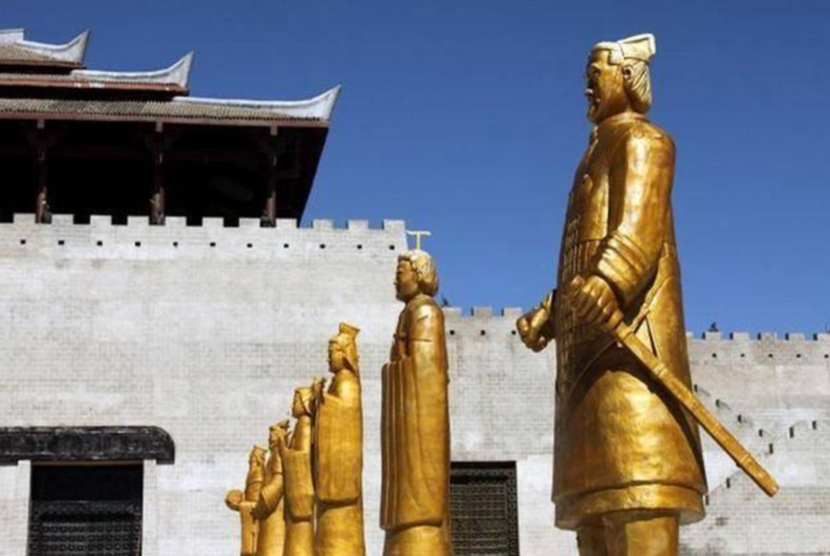

(十二金人, 2020) - twelve gold statues

### **贫 – Poverty**

Beyond the minimum threshold of survival, the Qin dynasty systematically stripped people of their remaining wealth. The logic was simple: satiation, warmth, and comfort breed selfishness and disobedience. By ensuring the ordinary people lacked adequate food and clothing, they would not only lose the motivation to struggle but also be less likely to entertain rebellious thoughts.

The Qin established an extremely harsh and intricate tax system. Field rents and head taxes together accounted for two-thirds of the annual harvest. According to the Book of Han, the Qin Dynasty levied taxes not on the actual amount of land one owned but on a predetermined number of acres per person as dictated by the court. Even if one’s land was destroyed by natural or man-made disasters, the expected tax quota remained unchanged.

In addition to these fixed taxes, there were also miscellaneous levies imposed at the court’s discretion. For instance, during a year of good harvests, people were required to pay extra to express gratitude for the emperor's grace. In years marked by natural disasters such as droughts or floods, the burden increased further, with additional taxes levied to fund river repairs, canal construction, or other state projects. Essentially, taxation was arbitrary: the court would demand whatever it desired, leaving the people no recourse to question or resist. The policy operated on the principle of "Do not ask what you think; obey what I command," draining the population of its last reserves of surplus food.

Both material poverty and spiritual barrenness were equally destructive. Having been systematically "fooled" into submission, the people became incapable of recognizing their plight. As long as they drew breath, they made no attempts at change, passing their days in stagnation and resignation. This cycle of generational despair ensured that they remained docile and pliable, perfectly suited to the Qin’s authoritarian system (Tangly, 2024).

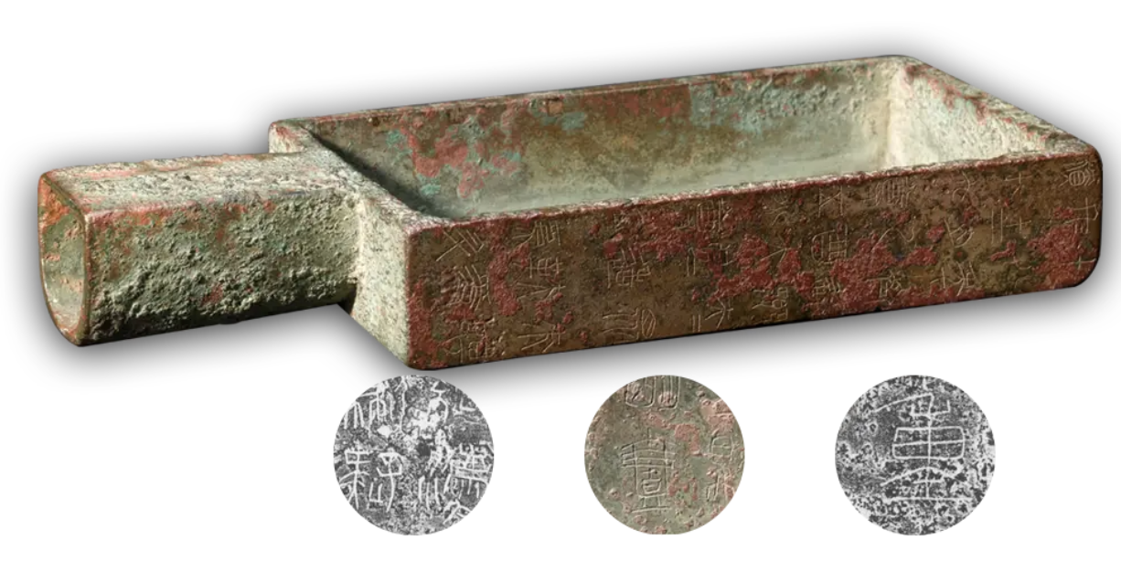

(文旅中国, 2021) - The Shang Yang Rectangular Capacity Measuring Vessel

The Shang Yang Rectangular Capacity Measuring Vessel was a standard measuring instrument introduced by Shang Yang during his efforts to unify weights and measures for the Qin State as part of his legal reforms. In 350 B.C., Qin relocated its capital to Xianyang and initiated its second wave of reforms. These included abolishing the outdated well-field system, establishing a new road and border system, implementing an equitable tax system, and standardizing weights and measures.

The Shang Yang Rectangular Measuring Vessel serves as tangible evidence of the implementation of standardized weights and measures during this period. It stands as an important artifact of Shang Yang's reforms, symbolizing the practical and administrative changes that were instrumental in the transformation of the Qin State (文旅中国, 2021).

### **疲 – Fatigue**

The heavy corvée system drained people's physical strength and energy. After Qin unified the world, numerous massive projects were completed in just over a decade, requiring a substantial amount of manpower. According to records, 400,000 people were employed in the construction of the Great Wall, over 700,000 were conscripted for the construction of the A-fang Palace and the Li-shan Palace, and tens of thousands were involved in building infrastructure such as the “Straight Road” the “Chi-road” and various waterways. This was a common practice under the Qin regime.

Corvée labor was unpaid, with workers even required to provide their own food and tools. Most conscripts were young and strong individuals who represented the primary labor force of their families. These families were left unable to cultivate their fields as their main laborers were conscripted for years to work without compensation. The fortunate ones returned home with injuries or illnesses, while the less fortunate lost their lives.

The tale of Meng Jiangnu weeping at the Great Wall is one such tragedy. Although a folk story, its enduring popularity and the widespread empathy it evokes suggest that it is rooted in the harsh realities of Qin's corvée system, reflecting the severity and brutality of forced labor during that time (Tangly, 2024).



(宗谱链, 2024) – Qin Great Wall

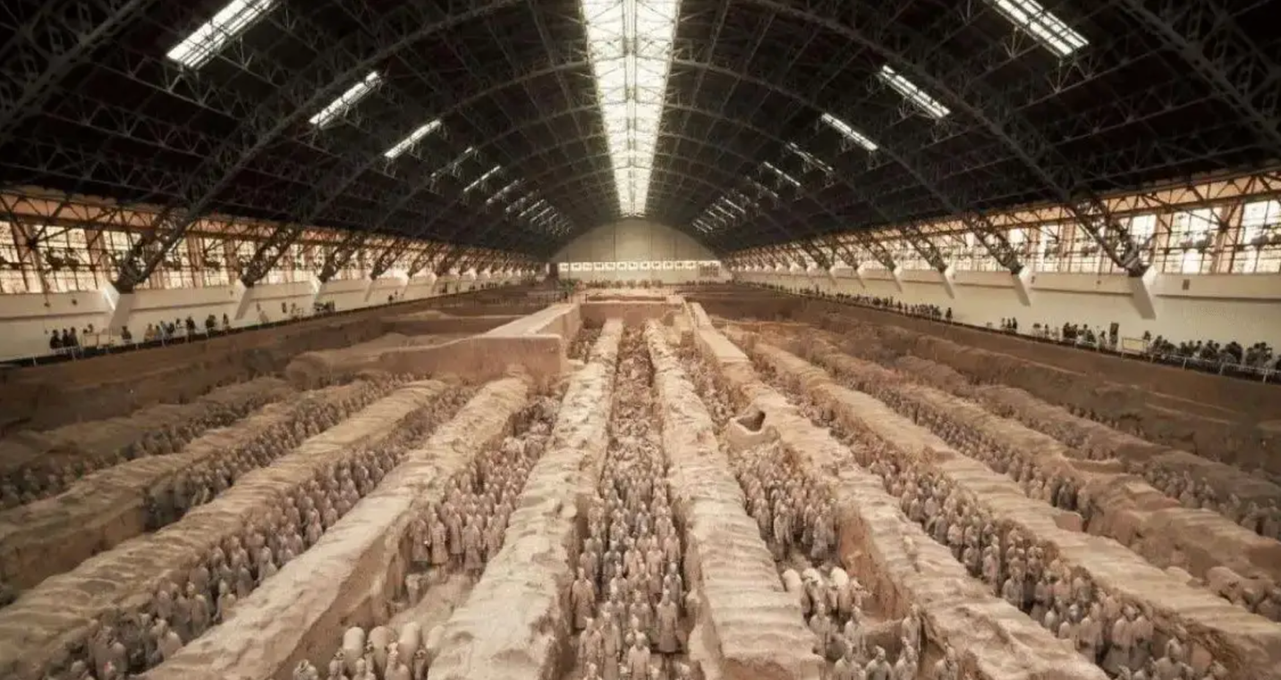

(宗谱链, 2024) – Li-shan Palace

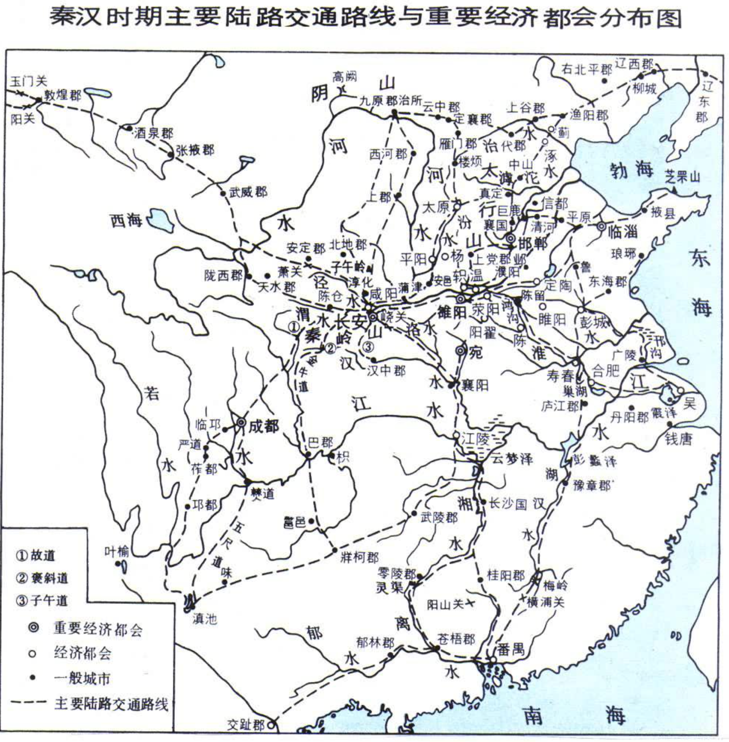

(中国大百科全书出版社, 2020) - the “Straight Road” the “Chi-road”

### **辱 - Humiliation**

In contemporary terms, this can be described as a form of PUA (Psychological Manipulation). Modern instances of PUA typically occur on a person-to-person or point-to-point basis. However, the system proposed in the Book of Shang Jun was an undifferentiated, systematic form of psychological manipulation imposed on the population by an enormous state apparatus.

The Qin Jian, unearthed at Sleeping Tiger Land, stipulates that when farmers plowed the land, they were to avoid looking around, listening, or speaking, akin to donkeys pulling millstones while blindfolded. People were treated as livestock, or perhaps even worse. For example, if the oxen raised by farmers were malnourished, the farmers themselves would be punished, ranging from flogging to execution in severe cases.

Additionally, the Book of Shang Jun advocated the abolishment of all material pleasures. Music, songs, dances, and ornaments were to be banned entirely, reducing people to mere instruments of production. The intent behind such systematic humiliation was clear: to suppress individuality and submission.

The book elaborates that when people are humiliated, they value noble titles; when made weak, they revere officials; and when impoverished, they covet rewards. This system created a society where individuals wagged their tails before their superiors, envying and idolizing them, while feeling pity and resentment for their inability to be part of the elite system.

In essence, the Book of Shang Jun proposed ideas entirely contrary to the people-centered values of modern society. Its initiatives drastically compressed the living space of ordinary people, curtailed their abilities, and reduced them to entities even lower than livestock—human "fuel" or humanoid "batteries." (Tangly, 2024).

## **Social and Historical Context of The Book of Lord Shang**

The Book of Lord Shang was written during the Warring States period (475–221 BCE), a time of political fragmentation and intense competition among rival states. Shang Yang, a prominent legalist and statesman in the State of Qin, authored this text to detail his legalist philosophy and reforms, which emphasized centralization, strict laws, and the suppression of individual freedoms to strengthen the state. These reforms allowed Qin to rise as a dominant power, ultimately unifying China under the Qin Dynasty in 221 BCE. The book served as a manual for rulers, outlining methods to maintain absolute control and build a strong state through the systematic weakening of the populace (文华道商,2019).

## **Endangerment and Banning of the Book**

The Book of Lord Shang was considered dangerous because it provided rulers with explicit strategies for authoritarian control, including methods to weaken the populace and ensure obedience. Its principles, rooted in Legalism, were instrumental in the rise of the Qin Dynasty, but its harsh policies were widely criticized following Qin’s fall. Subsequent dynasties officially embraced Confucianism, which emphasized moral governance and benevolence, as their state ideology. Emperor Wu of the Han Dynasty formalized this shift with his policy of "dismissing all schools of thought and honoring only the Confucians," marginalizing legalist works like The Book of Lord Shang.

Despite this public rejection, many rulers secretly employed the book's legalist principles to strengthen their regimes while outwardly endorsing Confucian ideals. This contradiction led to its restricted circulation, with access often limited to the imperial court and royal family. The book was deliberately kept hidden from the public to prevent its ideas from inspiring rebellion or enabling rivals to create powerful competing states. Even during the Tang and Song dynasties, known for their cultural and intellectual flourishing, the text remained inaccessible to the general populace.

The suppression of The Book of Lord Shang continued until the end of the Qing Dynasty, when the collapse of the feudal system allowed previously restricted texts to reappear. Its reemergence provided scholars and the public with insights into the legalist philosophies that shaped early Chinese statecraft. Today, while the book is no longer censored, it remains a controversial text studied for its impact on governance and political thought. Its historical endangerment underscores the enduring tension between state control and the dissemination of transformative, yet contentious, ideas.

## **Text Technology and Its Function**

The Book of Lord Shang was originally created using the text technologies of early Imperial China, likely including bamboo slips and ink. These were common mediums for writing during the Warring States Period (475–221 BCE), predating the invention of paper. The process of creating texts involved several steps. Bamboo was cut into uniform strips, smoothed, and polished to create a writable surface. Writing was done using a brush dipped in ink, typically made from soot, water, and an adhesive substance. Once written, the bamboo slips were tied together in sequence with cords to form scrolls. To preserve the text, the slips were stored in protected environments, shielded from humidity and pests that could cause decay (汉语堂, 2017).

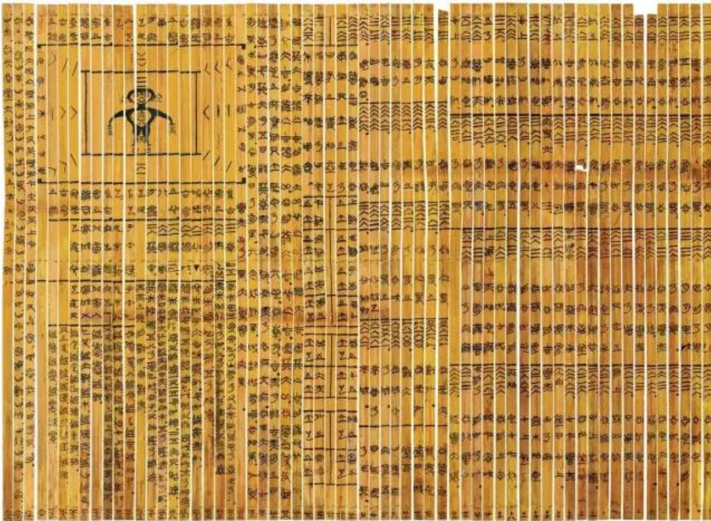

(汉语堂, 2017) - Bamboo Slips

## **Resources and Social Infrastructures**

The production and preservation of The Book of Lord Shang required significant resources and social infrastructure. The materials, such as bamboo and ink, were essential and needed to be of high quality. Skilled artisans were required to prepare the bamboo slips and to write the text legibly using brushes. Moreover, the creation of the text was likely supported by the state, as legalist works like The Book of Lord Shang were endorsed by the Qin court, which saw Shang Yang’s principles as foundational to governance. Preservation also relied on state archives or libraries, where the slips were maintained under controlled conditions.

## **Impact of the Technology on Text and Community**

The text technology of the time significantly influenced the accessibility and dissemination of The Book of Lord Shang. Because bamboo slips were bulky and required manual reproduction, the text was not easily portable or widely distributed. This limited access to educated elites, primarily scholars and officials, who had the knowledge and resources to engage with the text. Additionally, the durability of bamboo slips was limited; they were vulnerable to decay, fire, and physical damage, contributing to the risk of the text’s loss over time. Circulation was further restricted since copies had to be painstakingly reproduced by scribes.

## **Cultural and Technical Conditions: Endangerment and Afterlife**

The cultural and technical conditions surrounding the creation and preservation of The Book of Lord Shang also impacted its longevity. During the Qin dynasty, the text held a privileged status as its principles underpinned the state’s legalist policies. However, the rise of Confucianism during the Han dynasty marginalized legalist texts, endangering the book as fewer copies were reproduced. Periods of cultural upheaval, including Confucian-inspired purges, also targeted legalist works, threatening their survival. Despite these challenges, surviving copies in state archives ensured the text’s continuation, and archaeological discoveries of ancient bamboo slips in the 20th century have shed new light on its original form and production.

## **Conclusion**

The historical context of The Book of Lord Shang—encompassing politics, religion, culture, and text technologies—profoundly shaped its creation, dissemination, preservation, and vulnerabilities. Written during the Warring States Period (475–221 BCE), a time of political fragmentation and intense competition among Chinese states, the book encapsulated Shang Yang’s legalist philosophy. His ideas directly influenced the state-building efforts of Qin, which later unified China. The political motivations behind the text were clear: it served as a guide for governance, advocating centralized power, strict laws, and uniformity. These principles resonated with the Qin rulers, who implemented many of Shang Yang’s policies, tying the book’s fate to the political landscape.

The cultural and religious milieu of the time also played a significant role in the book’s journey. Legalism, the philosophy underpinning The Book of Lord Shang, stood in stark contrast to the Confucian values of ethics, family loyalty, and moral governance. During the Qin dynasty, legalist texts were promoted and preserved in state libraries as they aligned with the regime's ideology. However, the ascendancy of Confucianism during the Han dynasty (202 BCE–220 CE) relegated legalist texts to the margins, leading to their reduced reproduction and increasing risk of loss. The tension between these philosophical traditions left The Book of Lord Shang vulnerable during periods of cultural purges and Confucian dominance.

The text technologies of early Imperial China also significantly influenced the book’s transmission and preservation. Initially written on bamboo slips, the book required skilled artisans and labor-intensive processes for its production. Bamboo slips were cumbersome and fragile, making their widespread dissemination challenging. The reliance on state support for the maintenance of archives meant that the book’s survival was intricately tied to the political stability and priorities of the ruling class. During periods of upheaval, such as the fall of the Qin dynasty, many texts—including The Book of Lord Shang—were destroyed or lost. It was only through the preservation efforts of scholars and later archaeological discoveries that parts of the text survived.

Despite these vulnerabilities, The Book of Lord Shang provides unique insights into the relationship between text technologies and the transmission of knowledge. It demonstrates how text creation was both a technical and ideological act, shaped by the materials available and the socio-political agenda of its creators. The book’s survival also highlights the fragility of knowledge transmission, where cultural and technological changes could lead to the marginalization or rediscovery of ideas.

## **The Five Arts of Harnessing the People: Control in Everyday Life**

The principles outlined in *The Book of Lord Shang* extend far beyond governance, influencing various aspects of daily life, including the workplace, family, relationships, and marketing. In the workplace, performance incentives such as full attendance awards, performance pay, and year-end bonuses serve as subtle mechanisms of control—disguised deductions that keep employees focused on avoiding penalties rather than demanding higher wages. This ultimately benefits employers by maintaining productivity at minimal cost.

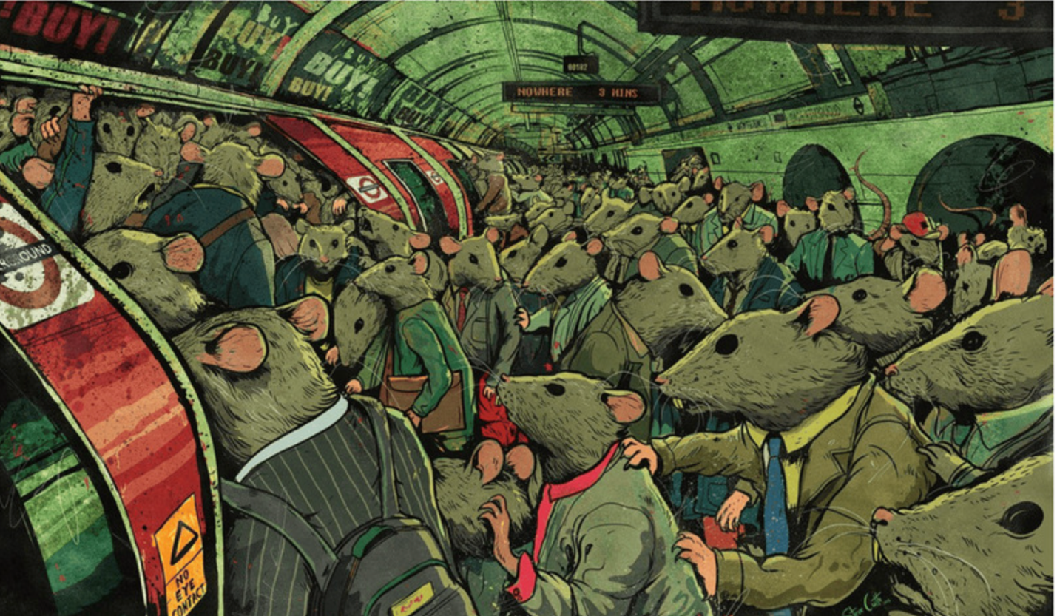

(Steve Cutts, Rat Race)

Similarly, in families, the concept of *favor theory* manifests in parental guilt-tripping, where parents expect obedience and gratitude for raising their children, despite it being their responsibility. Ironically, children raised with a sense of mutual duty rather than coerced gratitude tend to develop a more genuine appreciation for their parents. This psychological dynamic echoes broader societal structures that use obligation to ensure compliance.



(Global Times, “PUA” )

Governance follows the same principle. *The Book of Lord Shang* describes how rulers push individuals into hardship, forcing them to struggle for survival, only to make them feel grateful for merely staying afloat. This ensures that the common people remain preoccupied with survival rather than aspiring for more, while those in power enjoy exclusive privileges. The same technique is employed in relationships through psychological manipulation (such as *PUA techniques*), where individuals are subjected to emotional push-pull tactics to foster dependency. Marketing operates similarly by manufacturing a sense of need before providing a solution, exemplified by the "sell me this pen" scenario in *The Wolf of Wall Street*, where urgency is created rather than the product simply being promoted.



(sell me this pen)

### **The Illusion of Opportunity: Hierarchy, Resource Control, and Information Manipulation**

At the core of these mechanisms lies a deeper structural inequality, also highlighted in *The Book of Lord Shang*. Traditional social roles—scholars allocating resources, farmers producing raw materials, artisans crafting goods, and merchants distributing them—reflect a rigid hierarchy in which resource distribution is inherently unfair. Those in power take priority, while the common people receive only what remains, often feeling compelled to express gratitude for their meager share.

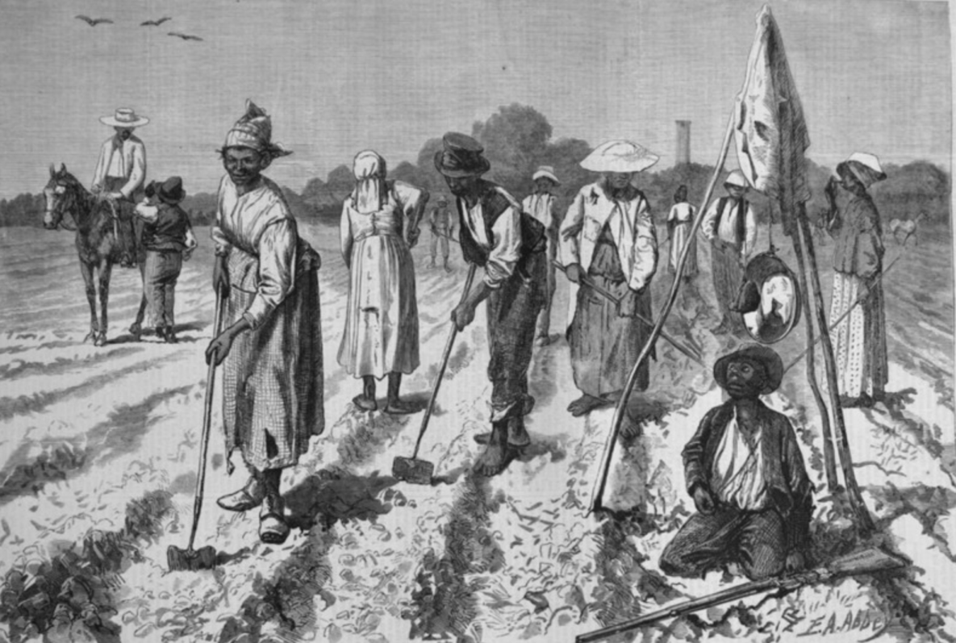

(Lisa Lennox, “Culture of Slavery”)

Confucian traditions reinforce this hierarchy, conditioning individuals not to dismantle the system but to aspire to rise within it and dominate others. This mindset sustains social stratification, ensuring that power remains concentrated at the top. Even more insidiously, information is carefully controlled to reinforce these divisions. While elites receive unfiltered intelligence, the lower classes are fed distorted, processed narratives, leading to decisions based on manipulated truths. This selective dissemination of knowledge ensures the continuation of systemic injustice, as misinformation keeps the masses compliant and unaware of alternatives.

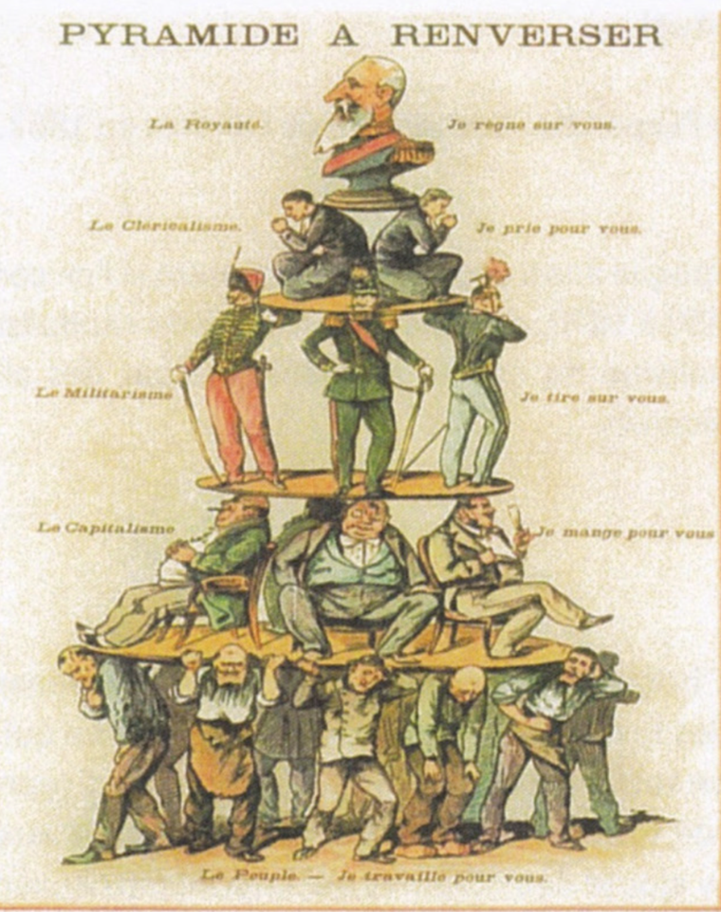

(Pyramide à renverser)

### **Education as a Tool of Control: The Limits of Culture and Cognition**

Culture does not always equate to progress. Practices like martyrdom, foot-binding, and extreme religious traditions are often upheld not as markers of civilization but as tools to reinforce existing power structures. By viewing history from a global perspective rather than through a single cultural lens, one can better recognize how certain traditions persist to serve the interests of specific groups rather than society as a whole.

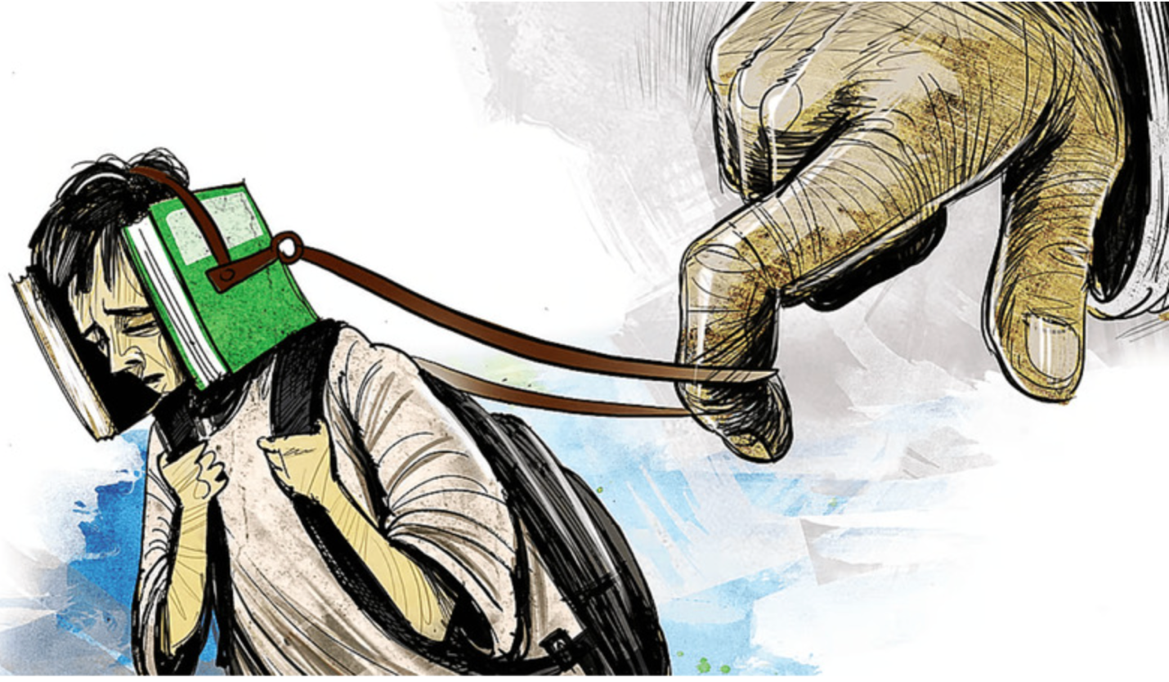

(Education as a Tool of Control)

Education, in particular, plays a pivotal role in this process. It is often portrayed as a means of intellectual empowerment, yet in reality, much of what is taught is selectively filtered to mold individuals into obedient members of society. Rather than fostering critical thinking, education frequently serves to instill compliance, ensuring that individuals internalize societal norms that ultimately benefit those in power. The supposed virtues of "benevolence" and "righteousness" are often mere rhetorical tools that obscure the true pursuit of power and profit.

### **The Book of Lord Shang: A Reflection of Its Own Teachings**

**

(The Book of Lord Shang)

A particularly striking aspect of *The Book of Lord Shang* is how its own existence mirrors its teachings on control. Just as the book advocates for the strict regulation of society, its transmission and preservation have been tightly controlled throughout history. This reflects an ongoing tension between knowledge as a means of empowerment and knowledge as an instrument of domination.

By examining *The Book of Lord Shang* through the lens of governance, information control, and cultural conditioning, we can see how its principles continue to shape modern life. This enduring relevance invites us to critically reflect on the structures we navigate daily, questioning not just the systems we live under, but also the ways in which knowledge itself is curated and controlled to sustain them.

## **Reference**

Shang Yang, “Shang Yang,” *Omeka*, accessed March 20, 2025, <https://omeka.ischool.utoronto.ca/items/show/30>.

Ancient Chinese script developers, “Chinese Character “民”,” *Omeka*, accessed March 20, 2025, <https://omeka.ischool.utoronto.ca/items/show/21>.

ChinaKnowledge.de. (n.d.). *Shangjunshu 商君書 "Book of Lord Shang"*. <http://www.chinaknowledge.de/Literature/Diverse/shangjunshu.html#:~:text=Shangjunshu%20%E5%95%86%E5%90%9B%E6%9B%B8%22Book,private%20ownership%20(qianmo%20%E9%98%A1%E9%99%8C)>.

Pines, Y. (2017). The Book of Lord Shang: Apologetics of State Power in Early China. Columbia University Press.

<https://cup.columbia.edu/book/the-book-of-lord-shang/9780231179881#:~:text=About%20the%20Author,of%20thought%20in%20early%20China>.

Steve Cutts, “Rat Race,” *Omeka*, accessed March 20, 2025, <https://omeka.ischool.utoronto.ca/items/show/31>.

Lisa Lennox, “Culture of Slavery,” *Omeka*, accessed March 20, 2025, <https://omeka.ischool.utoronto.ca/items/show/32>.

“sell me this pen,” *Omeka*, accessed March 20, 2025, <https://omeka.ischool.utoronto.ca/items/show/34>.

Global Times, “PUA,” *Omeka*, accessed March 20, 2025, <https://omeka.ischool.utoronto.ca/items/show/36>.

Russian flyer of c, “Pyramide à renverser,” *Omeka*, accessed March 20, 2025, <https://omeka.ischool.utoronto.ca/items/show/33>.

Atanu Dey, “Education as a Tool of Control,” *Omeka*, accessed March 20, 2025, <https://omeka.ischool.utoronto.ca/items/show/35>.

文华道商. (2019). 被称作“天下第一禁书”的《商君书》，它到底有什么神秘之处？Baidu Baike <https://wapbaike.baidu.com/tashuo/browse/content?id=375a76c4d6d17cb9f1b9d11c>

[风尘讲历史](https://www.sohu.com/a/741960468_120074437?spm=smpc.content-abroad.content.1.1737477903524Leo8ugl). (2023). **《商君书》为何是古代第一禁书？**

<https://www.sohu.com/a/741960468_120074437>

(沈烈康,2025). 商鞅的“驭人五术”是指什么，对中国危害有多大？. Sohu.com. <https://www.sohu.com/a/850190310_121630958?scm=10008.1479_13-1479_13-68_68.0-3328004.0.0&spm=smpc.content-abroad.fd-d.8.1737334355644XV3jEv1>

商鞅戟. (2015). [ShanghaiMuseum.net](http://ShanghaiMuseum.net)

<https://www.shanghaimuseum.net/mu/frontend/pg/m/article/id/CI00000511>

十二金人 (2020) 秦始皇为什么要铸造十二金人？

<https://www.sohu.com/a/368319383_120476029>

Tangly. (2024). 天下第一禁书有哪些可怕之处？为什么普通人永远不要阅读？

<https://blog.tangly1024.com/article/shang-yang-bian-fa#144f93b9208b80b98111d34839e35510>

文旅中国. (2021). 看见文物 | 商鞅变法的重要物证. Sohu.

<https://www.sohu.com/a/470204677_120006290>

宗谱链. (2024). **秦朝时期的著名建筑工程有哪些？**

<https://www.sohu.com/a/783888999_120100667>

中国大百科全书出版社. (2020). 秦驰道、直道构建了以首都咸阳为中心辐射全国的交通干线

<https://h.bkzx.cn/knowledge/1745>

赵奇.(2018). 《商鞅变法》. 中国国家画院.

<http://www.cnap.org.cn/cnap/zuopxs/201803/7b45f3c46748428b8b70b21fef6e3fad.shtml>

汉语堂.（2017). 竹简上的文字是如何书写的？ <https://www.sohu.com/a/154434906_312708>